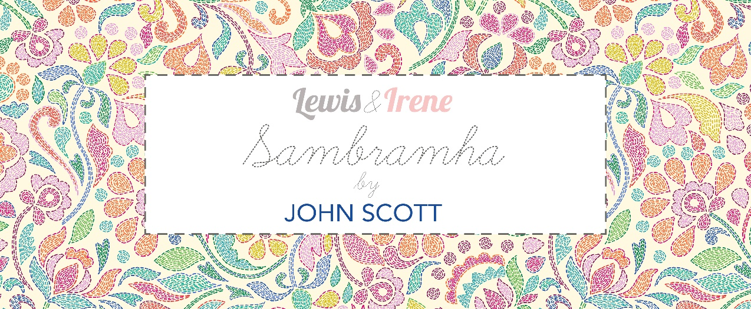
Designed and made by Sally Ablett
Size of runner 68" x 68" - unfinished block size 4½" x 4½"
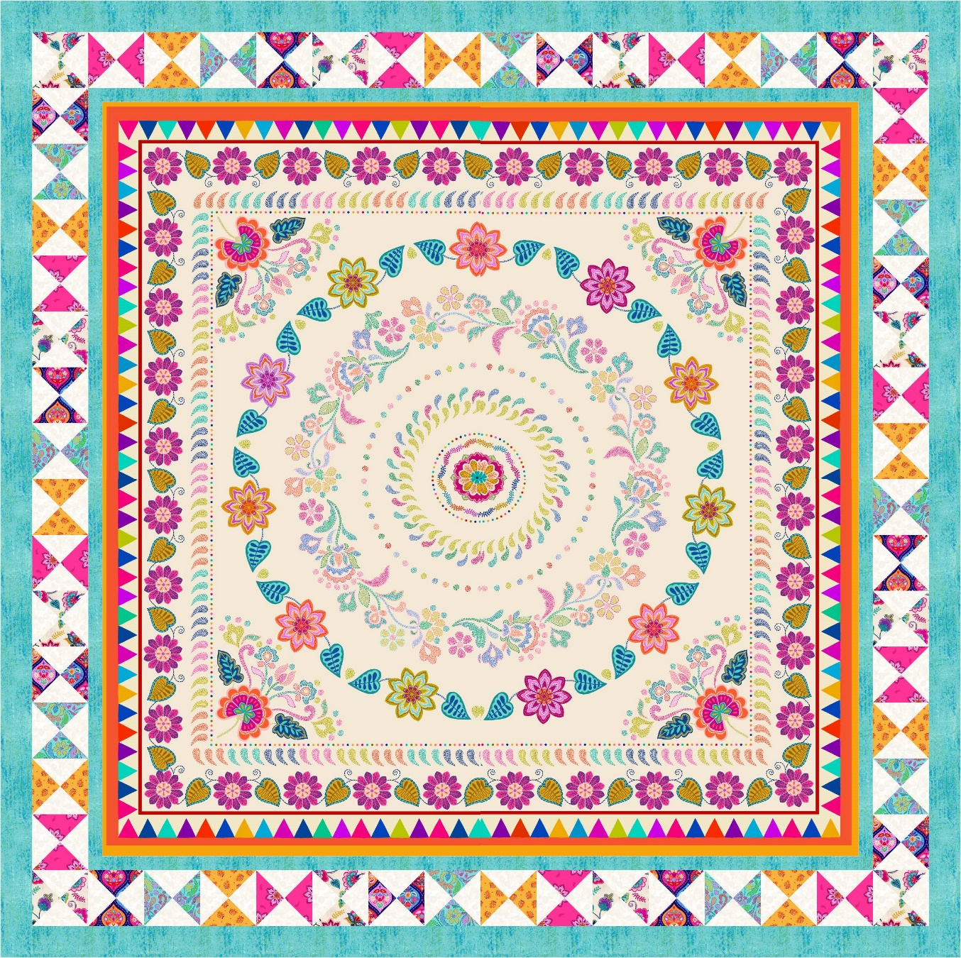
Main Diagram
Fabrics from Sambramha collection
Requirements
- A975 - Sambramha quilt panel
- A976A - Sambramha floral on cream - fat ¼
- A977B - Jewel drops dark - fat ¼
- A978A - Mini stems on yellow spice - fat ¼
- A979B - Celebration flower turquoise - fat ¼
- A980B - Sambramha stitches on turquoise - fat ¼
- A981A - Sambramha blender turquoise - 1½yd - 1½m
- BB01 - White - ⅞yd - ⅞m
Wadding and backing 76" x 76"
All measurements include ¼" seam allowances; press each seam as you go.

Cutting
From fabric 1 cut
54½" x 54½" square quilt panel
From each of the fabrics 2, 3, 4, 5, and 6 cut (hourglass blocks)
1 x 5½" x WOF strip
Subcut: 5 x 5½ x 5½” squares
Cut each square in half diagonally twice
From fabric 7 cut (hourglass blocks and borders)
1 x 5½” x WOF strip
Subcut: 5 x 5½ x 5½” squares
Cut each square in half diagonally twice
7 x 2½" x WOF strips
Make: 2 x 2½” x 64½" (outer side borders)
Make: 2 x 2½” x 68½" (outer top and bottom borders)
6 x 1½" x WOF strips
Make: 2 x 1½” x 54½" (inner side borders)
Make: 2 x 1½” x 56½" (inner top and bottom borders)

From fabric 8 cut (hourglass blocks)
5 x 5½" x WOF strip
Subcut: 30 x 5½ x 5½” squares
Cut each square in half diagonally twice
Making up the block
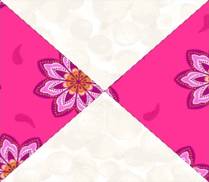 Border block
Lay out the fabric pieces for your block as in the main diagram. Sew two small triangles together to make a larger triangle and then sew them together to make a square. Make up all the blocks in the same way. Trim blocks to 4½” square.
Making up the quilt
Inner border
Stitch the side strips to the quilt and then the top and bottom.
Middle border
Lay out all the blocks as in the main diagram. Sew the side blocks together and stitch to the quilt. Do the same to the top and bottom blocks.
Outer border
Stitch the side strips to the quilt and then the top and bottom to complete the quilt.

Quilting and binding
Sandwich the quilt top, wadding and backing together.
Quilt by hand or machine as desired. Trim the backing and wadding to size of quilt.
Use your favorite method to bind the quilt.

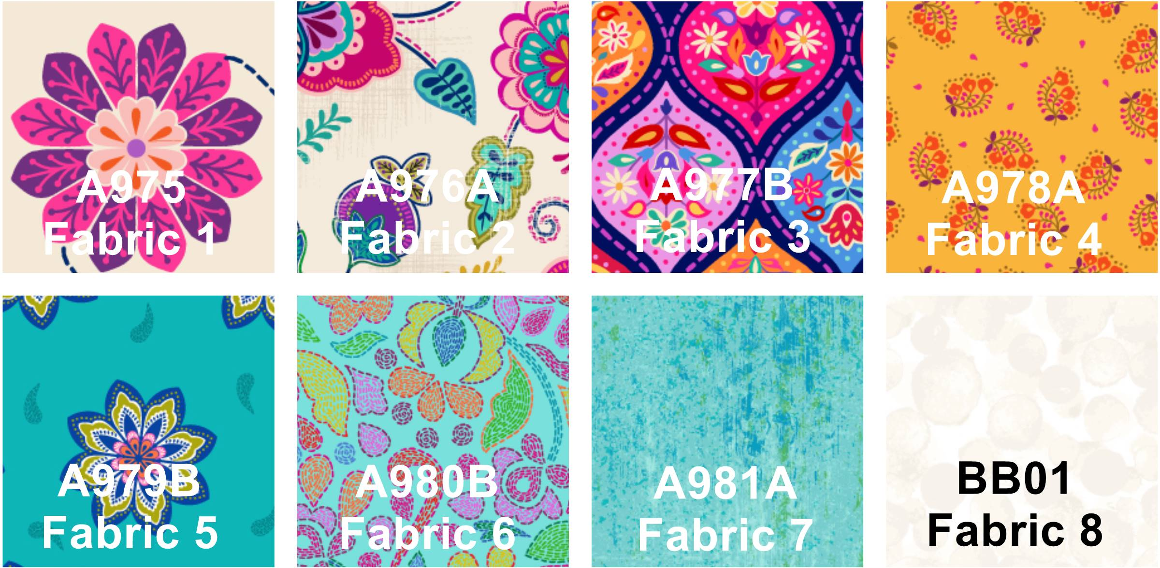
Sally Ablett © 2026

